

Semester One Examination, 2021

Question/Answer booklet

MATHEMATICS METHODS
UNIT 3

Section Two:

Calculator-assumed

Your Name:
Your Teacher’s Name:

Time allowed for this section
Reading time before commencing work: ten minutes
Working time: one hundred minutes

Materials required/recommended for this section
To be provided by the supervisor
This Question/Answer booklet
Formula sheet (retained from Section One)

To be provided by the candidate
Standard items: pens (blue/black preferred), pencils (including coloured), sharpener, correction fluid/tape, eraser, ruler, highlighters

Special items: drawing instruments, templates, notes on two unfolded sheets of A4 paper, and up to three calculators approved for use in this examination

Important note to candidates
No other items may be taken into the examination room. It is your responsibility to ensure that you do not have any unauthorised material. If you have any unauthorised material with you, hand it to the supervisor before reading any further.

Question | Marks | Max | Question | Marks | Max
8 |  | 7 | 14 |  | 9
9 |  | 9 | 15 |  | 8
10 |  | 6 | 16 |  | 7
11 |  | 10 | 17 |  | 8
12 |  | 8 | 18 |  | 7
13 |  | 9 | 19 |  | 8

Structure of this paper

Section | Number of questions available | Number of questions to be answered | Working time (minutes) | Marks available | Percentage of examination
Section One:  Calculator-free | 7 | 7 | 50 | 50 | 34
Section Two:  Calculator-assumed | 12 | 12 | 100 | 96 | 66
 |  |  |  | Total | 100

Instructions to candidates

- The rules for the conduct of the Western Australian Certificate of Education ATAR course examinations are detailed in the Year 12 Information Handbook 2019. Sitting this examination implies that you agree to abide by these rules.

- Write your answers in this Question/Answer booklet.

- You must be careful to confine your answers to the specific questions asked and to follow any instructions that are specific to a particular question.

- Additional pages for the use of planning your answer to a question or continuing your answer to a question have been provided at the end of this Question/Answer booklet. If you use the space to continue an answer, indicate in the original answer space where the answer is continued, i.e. give the page number.

- Show all your working clearly. Your working should be in sufficient detail to allow your answers to be checked readily and for marks to be awarded for reasoning. Incorrect answers given without supporting reasoning cannot be allocated any marks. For any question or part question worth more than two marks, valid working or justification is required to receive full marks. If you repeat any question, ensure that you cancel the answer you do not wish to have marked.

- It is recommended that you do not use pencil, except in diagrams.

- The Formula sheet is not to be handed in with your Question/Answer booklet.

Section One: Calculator-assumed (96 Marks)

This section has twelve questions. Answer all questions. Write your answers in the spaces provided.

Spare pages are included at the end of this booklet. They can be used for planning your responses and/or as additional space if required to continue an answer.
● Planning: If you use the spare pages for planning, indicate this clearly at the top of the page.
● Continuing an answer: If you need to use the space to continue an answer, indicate in the original answer space where the answer is continued, i.e. give the page number. Fill in the number of the question that you are continuing to answer at the top of the page.

Working time: 100 minutes.

Question 8 (7 marks)

(a) Differentiate (1 mark)
Solutions
Specific Behaviours
- Determines the correct expression derivative

A function $y=f(x)$ has a gradient function given by with .

(b) Determine the value for $f\left(3\right).$ (3 marks)
Solutions
Specific Behaviours
- Determines the correct expression for $f\left(x\right)$ with C
- Solves for the correct C
- Determines the correct value for $f(3)$

(b) Determine the $x$ values of the Point of Inflection for the function $f\left(x\right).$ (3 marks)
Solutions
Specific Behaviours
- Determines the correct expression for $f''\left(x\right)$
- Equates $f''(x)$ to 0 and solve for $x$
- States both $x$ values for $P.O.I.$ (Accept decimal approx.)
Question 9 (9 marks)

The graph below shows the function $f(x)$ with the following values.

$$x$$ | 0 | 0.2 | 0.4 | 0.6 | 0.8 | 1
$$f(x)$$ | 1 | 1.33 | 1.57 | 1.75 | 1.89 | 2

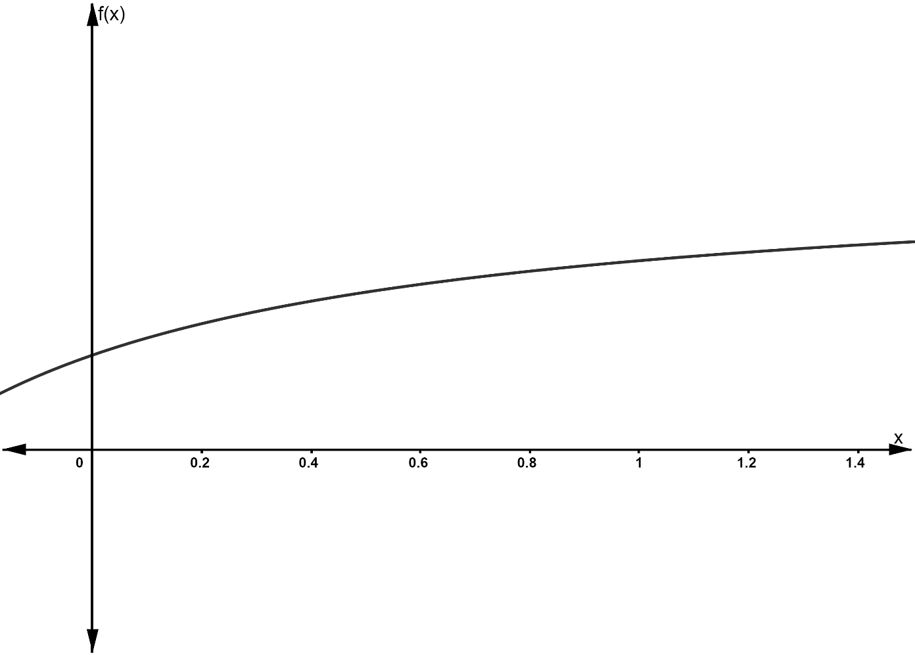

You are required to estimate the area under the curve between $x=0$ and $x=1$ using rectangles.

(a) Use the appropriate rectangles to calculate an under-estimate of the area (3 marks)

Solution
Area = 0.2(1+1.33+1.57+1.75+1.89) = 1.508 square units
Specific behaviours
- Uses LHS endpoints of rectangles
- Shows sum of areas of rectangles
- Correct area

(b) Use the appropriate rectangles to calculate an over-estimate of the area (3 marks)

Solution
Area = 0.2(1.33+1.57+1.75+1.89+2) = 1.708 square units
Specific behaviours
- Uses RHS endpoints of rectangles
- Shows sum of areas of rectangles
- Correct area

(c) Use your two values above to estimate the area under the curve between $x=0$ and $x=1$
(1 mark)

Solution
Area = (1.508 + 1.708)/2 = 1.608 square units

Specific behaviours
- States the average of the two values

(d) States at least two different ways to improve the estimation. (2 marks)

Solution
- Reduces the width of the interval
- Uses integral(Calculus) to evaluate the area
- Models parabolas between pairs of known points
Specific Behaviours
- States one reasonable way
- States two reasonable ways

Question 10 (6 marks)

Suppose that the amount of money in a bank account is given by

$$f\left(t\right)=-150 sin\left(t\right)+100 cos\left(t\right)+100$$
where $t$ is in years.

(a) During the first 10 years in which the account is open, determine the time interval when the amount of money in the account is increasing. Round your answer to one decimal place.
(3 marks)

Solutions
$$f'(t)=-150 cos\left(t\right)-100 sin\left(t\right)=0$$
$$-150\cos\left(t\right)=100 sin\left(t\right)$$
$$\tan\left(t\right)=-\frac{3}{2} \\ Solve(tan\left(t\right)=-\frac{3}{2}|0≤t≤10)$$
$$t=2.2, 5.3, 8.4$$

As $f^{'}\left(0\right)<0,$the intervals for $f^{'}\left(t\right)>0$are $2.2<t<5.3$ and $8.4<t<10$.

Specific Behaviours
- Determines the correct $f^{'}\left(t\right)$ OR sketches the function over domain
- Determines the correct values for $t$ when $f^{'}\left(t\right)=0$
- Determines the correct intervals (allows inclusion of endpoints)

(b) During the first 10 years in which the account is open, determine the time when the account peaks at its maximum balance. (3 marks)

Solutions
$$f\left(0\right)=200, f\left(5.3\right)≈280, f\left(10\right)≈98$$

Therefore, maximum balance occurs around 5.7 years.

Specific Behaviours
- Uses calculus or compares values to justify
- Determines the correct time (2 marks)

Question 11 (10 marks)

Kaylee is practising archery and has 15 arrows. She is shooting a target from a distance, and the probability that she shoots the target is 0.25.

- State the distribution for the situation above. (1 mark)
Solutions
$$X\sim Bin(15, 0.25)$$
Specific Behaviours
✓ States a binomial distribution with correct parameters

- What is the probability that she shoots the target 5 times? (2 marks)
Solutions
$$P\left(X=5\right)=0.16515$$
Specific Behaviours
✓ Uses $P(X=5)$
✓ Calculates the correct probability (2 marks for CORRECT answer)

- What is the probability that she shoots the target more than 4 times? (2 marks)
Solutions
$$P\left(X>4\right)=P\left(X≥5\right)=0.31351$$
Specific Behaviours
✓ Recognises $P\left(X>4\right)=P(X≥5)$
✓ Calculates the correct probability (2 marks for CORRECT answer)

- What is the expected number of times that she will shoot the target? (2 marks)
Solutions
$$E\left(X\right)=np$$
$$E\left(X\right)=15×0.25=3.75$$
Specific Behaviours
✓ Uses $E\left(X\right)=np$
✓ Calculates the correct expected value (2 marks for CORRECT answer)

- If she wants to shoot the target at least 4 times and ensure the probability of this occurring is at least 82%, what minimum number of attempts to shoot the target should she make? (3 marks)
Solutions
We want: $P\left(Y≥4\right)≥0.82$
where $Y\sim Bin(n, 0.25)$

If $n=20$, $P\left(Y≥4\right)=0.77484$
If $n=21$, $P\left(Y≥4\right)=0.80832$
If $n=22$, $P\left(Y≥4\right)=0.83761$

Thus $n=22$
Specific Behaviours
✓ Recognises that $P\left(Y≥4\right)≥0.82$
✓ Shows at least two attempts with different values for the number of trials
✓ Determines that $n=22$

Question 12 (8 marks)

A stuffed toy rabbit comes with 1, 2, 3, 4 or 5 toy baby bunnies included the box. (The number of baby bunnies is not known to the buyer until they open the box.)

The discrete random variable $X$ represents the number of baby bunnies in the box, and the table below shows a partial probability distribution for $X$.

$$x$$ | 1 | 2 | 3 | 4 | 5
$$P(X=x)$$ | $$a$$ | 0.21 | $$b$$ | 0.35 | 0.08

(a) Given that a buyer is 3 times as likely to find three baby bunnies in a box as just one, determine the values of $a$ and $b$. (2 marks)
Solution
$b=3a$ and $a+0.21+b+0.35+0.08=1$

$a=0.09$ and $b=0.27$

Specific behaviours
uses two equations for $a$ and $b$
obtains correct values

(b) Calculate the expected number of baby bunnies in the box. (2 marks)

Solution
$$E\left[X\right]=1×0.09+2×0.21+3×0.27+4×0.35+5×0.08 \\ =3.12$$

Specific behaviours
shows calculation for $E[X]$
obtains correct value

(c) Yuko wants Sam to have some of these baby bunnies for his birthday. She knows that he will be disappointed if he gets fewer than five baby bunnies. She decides to buy two of the toys(boxes) so that she can combine the baby bunnies if necessary. Calculate the probability that two boxes will contain a total of at least five baby bunnies (4 marks)

Solution
Let $Y$ denote the total number of baby bunnies in the two boxes.

$$P\left(Y≥5\right)=1-P\left(Y<5\right) \\ =1-P\left(Y=2\right)-P\left(Y=3\right)-P\left(Y=4\right)$$$=1-0.09×0.09-0.09×0.21-0.21×0.09-0.21×0.21$-0.09(0.27)-0.27(0.09)$$=0.8614$$

Specific behaviours
attempts to calculate either $P\left(Y≥5\right)$ directly, or $1-P(Y<5)$
correctly identifies cases (2nd line of equation)
shows calculations for each case (3rd line of equation)
obtains correct value

Question 13 (9 marks)

Under normal conditions, the concentration of a particular kind of algae in a pond can increase continuously at an instantaneous rate of 18% per day. On a certain day, this kind of algae is accidentally introduced into the pond, and its initial concentration in the water is 0.03 $g/{cm}^{3}$. Let $t$ stand for the number of days since the algae was introduced; and let $C(t)$ stand for the concentration of algae (in $g/{cm}^{3}$) after $t$ days.

(a) Write an equation that expresses $C(t)$ in terms of $t$. (1 mark)

Solution
$$C(t)=0.03e^{0.18t}$$
Specific behaviours
obtains correct equation for $P$

(b) Determine (to 2 decimal places) the concentration of algae in the pond after 7 days.
(2 marks)
Solution
$$C(t)=0.03e^{0.18t} \\ =0.03e^{0.18×7} \\ ≈0.11 g/{cm}^{3}$$

Specific behaviours
substitutes $t=7$
obtains correct value to 2 decimal places(no need for units)

(c) The water in this pond will become toxic to frogs if the concentration of algae exceeds $0.2 g/{cm}^{3}$. On which day after the introduction of the algae will the water become toxic to frogs?
(3 marks)
Solution
$$0.2=0.03e^{0.18t} \\ t≈10.5$$
Therefore, the water will become toxic to frogs on the 11th day after the algae was introduced.
Specific behaviours
substitutes $C=0.2$
solves for $t$
states the 11th day

(d) A particular treatment been shown to cause the concentration of algae in pond water to decline continuously at an instantaneous rate of 76% per day. If this treatment is introduced to the pond when the concentration is $0.16 g/{cm}^{3}$, determine after how many days (since starting the treatment) the concentration of algae in the pond will be less that $0.001 g/{cm}^{3}$.

Solution
$$0.001=0.16e^{-0.76t} \\ t=6.67$$
Therefore, the concentration will fall below $0.001 g/{cm}^{3}$on the 7th day after the treatment was started.
Specific behaviours
writes correct equation
solves for $t$
states the 7th day(accept 6.67days)

Question 14 (9 marks)

A prism has an equilateral triangle as its base.
$$h$$

(a) Show that the area of the triangular face is (2 marks)

Solution
Let $b$ be the length of the base of the triangle. Then
$$A=\frac{1}{2}bh$$

Now
$$\tan{60}=\frac{h}{\frac{1}{2}b} \\ \frac{1}{2}b=\frac{h}{\sqrt{3}}$$
Hence
$$A=\frac{h^{2}}{\sqrt{3}}$$

Specific behaviours
uses formula $A=\frac{1}{2}bh$
obtains correct formula in terms of $h$ using tangent ratio

(b) Showing use of the incremental formula, determine the approximate change in area of the triangle if it increases in size such that the perpendicular height changes from 5 cm to 5.1 cm (the triangle is scaled such that it remains equilateral). Give your answer to 2 decimal places.
(3 marks)
Solution
From part (a)
$$A=\frac{h^{2}}{\sqrt{3}}$$
and so
$$\frac{dA}{dh}=\frac{2}{\sqrt{3}}h$$
Now
$$\frac{ΔA}{Δh}≈\frac{2}{\sqrt{3}}h$$
so
$$ΔA≈\frac{2}{\sqrt{3}}×5×0.1 \\ ≈0.58 {cm}^{2}$$
Specific behaviours
determines derivative $\frac{dA}{dh}$
uses the fact that $\frac{ΔA}{Δh}≈\frac{dA}{dh}$
obtains correct value(no need for units)
(c) The height of the prism (that is, the distance between the triangular faces) is twice the perpendicular height of its triangular base. Showing use of the incremental formula, determine the approximate percentage change in the volume of the prism if all side lengths are increased by $2\%$. (4 marks)
$$h$$
prism height

Solution
If all side lengths increase by $2\%$, then the perpendicular height of the base increases by $2\%$.

Let $V$ represent the volume of the prism. Then
$$V=\frac{h^{2}}{\sqrt{3}}×2h \\ =\frac{2}{\sqrt{3}}h^{3}$$
and so
$$\frac{dV}{dh}=2\sqrt{3}×h^{2}$$
Now
$$\frac{ΔV}{Δh}≈\frac{dV}{dh}$$
and
$$\frac{ΔV}{V}≈\frac{2\sqrt{3}×h^{2}×Δh}{\frac{2}{\sqrt{3}}h^{3}} \\ ≈3×\frac{Δh}{h} \\ ≈3×0.02 \\ ≈0.06$$

Hence the volume increases by approximately $6\%$.

Specific behaviours
determines formula for $V$ in terms of $h$
determines the derivative $\frac{dV}{dh}$
attempts to determine approximate expression for $\frac{ΔV}{V}$ using the fact that $\frac{ΔV}{Δh}≈\frac{dV}{dh}$

obtains correct approximate value for percentage change in $V$

Question 15 (8 marks)

A dodecahedral die has twelve pentagonal faces numbered 1 to 12. A year ten mufti day advocacy stall proposes a game that involves paying $2 to roll a dodecahedral die 10 times with a 1 being the winning number. Possible prizes are as follows: If a player rolls a 1 twice out of the ten times, they win $5; if they roll a 1 more than twice, they win $10; and no prize is awarded otherwise. The year tens would like your help in the calculations below to help them decide if they should adjust their prize structure.

(a) Calculate the probability that after paying $2 for a game, a player wins
(i) A prize of $5 (2 marks)

Solution
$$X \sim Bin(10, \frac{1}{12})$$

$$P(X = 2) = 0.1558$$
Specific behaviours
- Defines the distribution
- Calculates the probability

(ii) A prize of $10 (1 mark)

Solution
$$P(X ≥ 3) = 0.0445$$

Specific behaviours
- Calculates the probability

(b) What is the probability that less than 11 out of the next 15 players will not win a prize? (2 marks)

Solution
$$Y \sim Bin (15, 0.7997)$$

$$P(Y ≤ 10) = 0.1649$$

Specific behaviours
- Defines the new distribution
- Calculates the probability
(c) What profit should the stall expect to make if 30 students participate in the game, each paying $2 to play as proposed? (3 marks)

Solution
$$Let W be the profit per player$$

$$P(W=2) = 0.7997$$

$$P(W= –3) = 0.1557$$

$$P(W= –8) = 0.0445$$

$$E(W) = 0.7762$$

$$Expected Profit = 30 × E(W) = \$23.29$$

Specific behaviours
- Shows probability distribution
- Calculates expected value per player
- Calculates expected value for 30 players

Question 16 (7 marks)

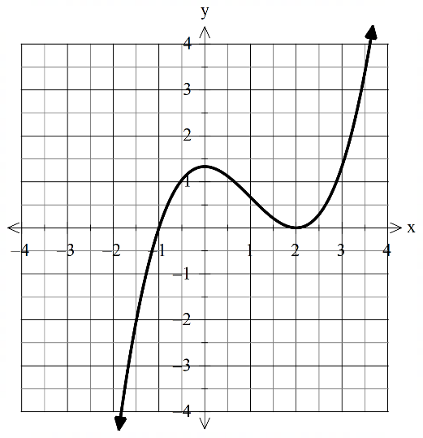
The graph of $y=f(x)$ is given below. It has turning points at $x=0$ and $x=2$.
Graphs are
$$y=\frac{{(x-2)}^{3}}{3}+({x-2)}^{2}$$
$$y={(x-2)}^{2}+2(x-2)$$
$$y=\frac{{(x-2)}^{4}}{12}+\frac{{(x-2)}^{3}}{3}-1$$

(a) At $x=1$, the graph of $y=f(x)$ has a point of inflection with an instantaneous gradient of $-1$. Use this information to sketch the graph of $y=f'(x)$ on the axes below. Label key features.
(3 marks)

Solution
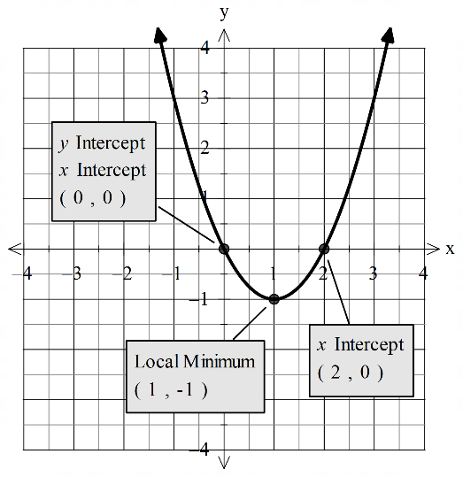
Specific behaviours
Shows concave up parabola
Labels local minimum at $(1,-1)$
Labels $x$-intercepts at $x=0$ and $x=2$

(b) The function $g$ is such that $\frac{d}{dx}\left(g\left(x\right)\right)=f(x)$, and $g\left(2\right)=-1$. Sketch the graph of $y=g(x)$ on the axes below, indicating all important features.
(4 marks)

Solution
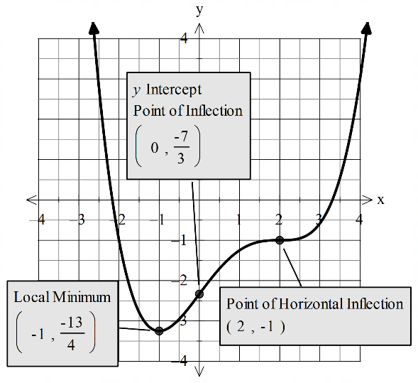
Specific behaviours
Marks horizontal point of inflection at $(2,-1)$
Labels local minimum at $x=-1$ (approx.)
Shows point of inflection at $x=0$
Sketches the correct overall shape

Question 17 (8 marks)
The Fresnel function below is used in modelling the diffraction of light waves:
$$S\left(x\right)=\int_{0}^{x}{\sin\left(\frac{πt^{2}}{2}\right)dt}$$
(a) Determine the functions for $S'(x)$ and $S''(x)$. (3 marks)
Solutions
$$S^{'}\left(x\right)=\frac{d}{dx}\int_{0}^{x}{\sin\left(\frac{πt^{2}}{2}\right)dt}=\sin\left(\frac{πx^{2}}{2}\right)$$

$$S^{''}\left(x\right)= πx\cos\left(\frac{πx^{2}}{2}\right)$$
Specific Behaviours
✓ Demonstrates the use of FTC to obtain $S'(x)$
✓ Applies the Chain Rule to find $S''(x)$
✓ Correctly obtains $S''(x)$

The graphs of $S'(x)$ and $S^{''}\left(x\right)$ are graphed on the axes below for $-0.5≤x≤2$
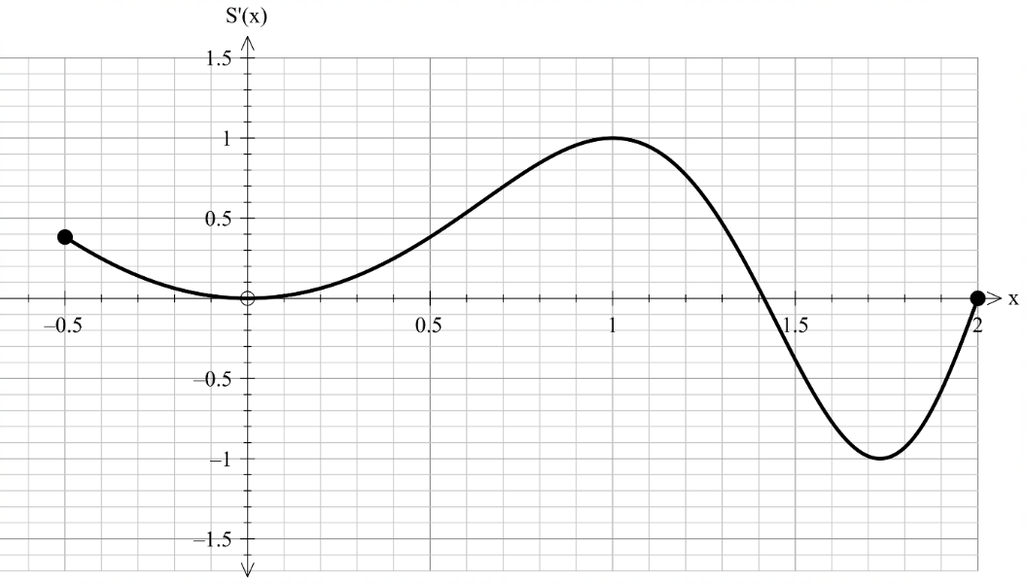
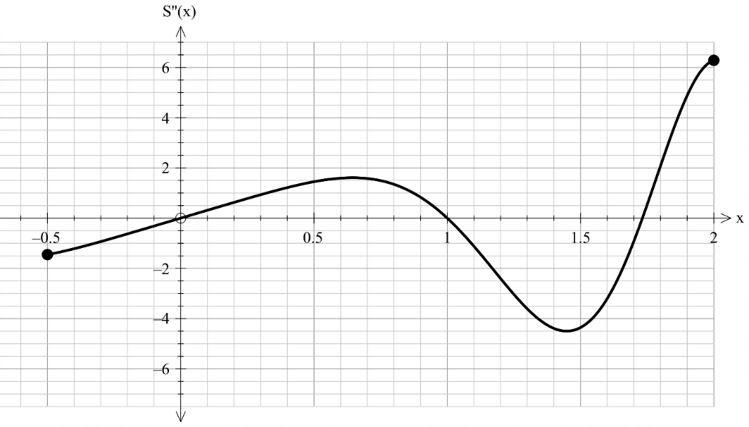

(b) Determine the $x$-coordinates for the stationary points of $S(x)$ and the nature of each stationary point, giving justification for your answer. (5 marks)
Solution
Stationary points at $x=0$, $x≈1.4$ and $x=2$as $S^{'}\left(x\right)=0$ at each of these points.

At $x=0$, $S^{''}\left(0\right)=0$ which means we have a horizontal point of inflection.

At $x≈1.4$, $S^{''}\left(1.4\right)<0$ which means we have a local maximum.

At $x=2$, $S^{''}\left(2\right)>0$ which means we have a local minimum.

Specific Behaviours
✓ Locates the correct $x$-values for the stationary points
✓ Justifies the stationary points using $S^{'}\left(x\right)=0$
✓ States the nature of $x=0$ as $S^{''}\left(0\right)=0$
✓ States the nature of $x≈1.4$ as $S^{''}\left(1.4\right)<0$
✓ States the nature of $x=2$ as $S^{''}\left(2\right)>0$

Question 18 (7 marks)

A horizontal cylindrical tank has cross-sectional area $A\left(x\right)=4\left(6x-x^{2}\right)$square meters at height $x$ meters above the bottom when $x≤3$.

(a) Given that the volume $V$ between heights $a$and $b$ is $\int_{a}^{b}{A\left(x\right) dx}$, determine the volume at heights between $2 m$ and $3 m$. (2 marks)

Solutions
$$\int_{2}^{3}{4\left(6x-x^{2}\right) dx}=\frac{104}{3}m^{3}$$

Specific Behaviours
- Sets up the correct integral
- Calculates the correct volume

(b) Suppose that oil is being pumped into the tank at a rate of $50m^{3}/min,$ using the chain rule,
$\frac{dx}{dt}=\frac{dx}{dV}×\frac{dV}{dt}$, determine the rate of change of height of oil in the tank with respect to time, in terms of $x$. (3 marks)

Solutions
$$\frac{dV}{dx}=\frac{d}{dx}\int_{a}^{x}{4\left(6z-z^{2}\right) dz}=4\left(6x-x^{2}\right)$$

$$\frac{dx}{dV}=\frac{1}{4\left(6x-x^{2}\right)}$$

$$Given\frac{dV}{dt}=50m^{3}/min, \frac{dx}{dt}=\frac{dx}{dV}×\frac{dV}{dt}=\frac{1}{4\left(6x-x^{2}\right)} 50=\frac{50}{4\left(6x-x^{2}\right)}$$

Specific Behaviours
- Uses F.T.C to determine an expression for $\frac{dV}{dx}$
- Uses inverse to hence determine an expression for $\frac{dx}{dt}$
- Uses the chain rule to determine the correct expression for $\frac{dx}{dt}$ in terms of $x.$

(c) Calculate the time (in minutes) that it takes to fill the tank from a fill level of $2 m$ to $3 m$. (2 marks)
Solutions
$$\frac{dx}{dt}=\frac{50}{4\left(6x-x^{2}\right)}$$

$$\frac{dt}{dx}=\frac{4\left(6x-x^{2}\right)}{50}$$

$$\int_{2}^{3}{\frac{4\left(6x-x^{2}\right)}{50}}dx=\frac{52}{75}min$$

$$Alternatively,\frac{104}{3}÷50=\frac{104}{150}=\frac{52}{75}min$$
Specific Behaviours
- Calculates the correct answer (2 marks)(no need for units)
Question 19 (8 marks)

When preparing to enter a road in a school zone, you hit the brakes on your car to reduce your speed to from $60 km/h$ to $40 km/h$ at a constant rate over $100 m$.

(a) Determine the acceleration in $m/s^{2}.$ Note that $1m/s^{2}≈12,960 km/h^{2}$. (6 marks)
Solutions
$$v\left(t\right)-v\left(0\right)=\int_{0}^{t}{a\left(t\right)} dt=at$$

$$v\left(t\right)=\int_{0}^{t}{a\left(t\right)} dt+v\left(0\right)=at+v\left(0\right)$$

$$Given v\left(0\right)=60, v\left(t\right)=40, 40=at+60$$

$$at=-20, t=-\frac{20}{a}(*)$$

$$x\left(t\right)-x\left(0\right)=\int_{0}^{t}{v\left(t\right)dt=\frac{at^{2}}{2}+60t}$$

$$x\left(t\right)=\frac{at^{2}}{2}+60t+x(0)$$

$$Given x\left(0\right)=0, x\left(t\right)=100 , 100=\frac{at^{2}}{2}+60t+0$$

$$Subitituting \left(*\right), \frac{a}{2}\left(\frac{400}{a^{2}}\right)+60\left(-\frac{20}{a}\right)=0.1$$

$$-\frac{1,000}{a}=0.1$$

$$a=-10,000km/h^{2}≈-0.7716 m/s^{2}$$

Specific Behaviours
- Uses FTC to write an expression for$v(t)$
- Express $t$ in terms of $a.$
- Uses FTC to write an expression for $x(t)$
- Obtains an equation in terms of $a$by substituting $t$ by $a$
- Solves for $a$ in $km/h^{2}$
- Coverts the answer to $m/s^{2}$

(b) At the same acceleration rate, determine the time (in seconds) it takes for you to bring your car to a complete stop from $60km/h.$ (2 marks)
Solutions
$$v\left(t\right)=0,$$

$$10,000 t+60=0$$

$t=\frac{60}{10000}h=21.6s$

Specific Behaviours
- Sets up an equation for $t.$
- Solves the correct $t$ in seconds (2 marks)
Additional working space
Question number: _______

Additional working space
Question number: ________

Additional working space
Question number: ________

